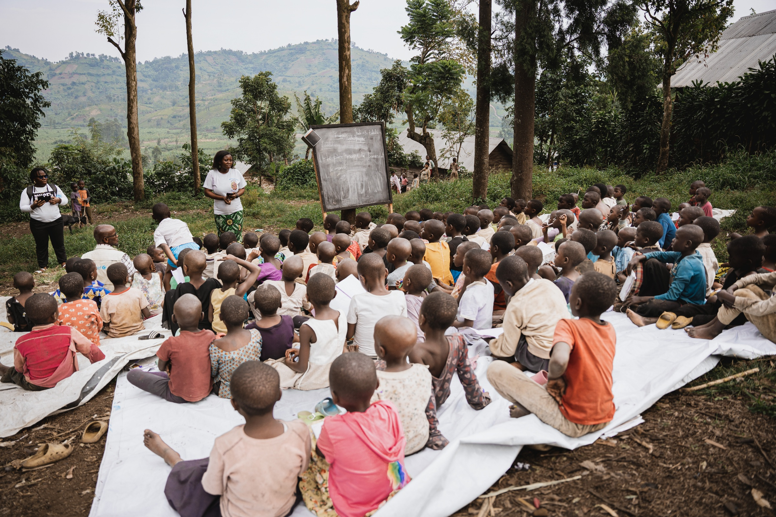
© UNICEF/UNI833286/Mirindi Johnson

Case Study
Pilot Project to Strengthen Collaboration in Child Protection and Education in Emergency Situations in North Kivu
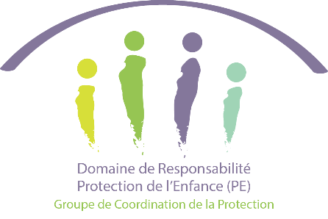

Context and Justification
Following the 2019 annual meeting of the Global Education Cluster, which focused on the protective role of education, the Child Protection Area of Responsibility (AoR) and the Education Cluster affirmed their shared commitment to strengthening coordination between their sectors. This momentum led to the creation of an intersectoral collaboration framework validated by the GEC and the CP AoR, which proposed concrete actions at each stage of the humanitarian programming cycle and now serves as a reference for countries wishing to operationalise this collaboration.
As a result, joint assessments on Protection in Education, common resource allocation strategies and joint advocacy initiatives have been carried out in several contexts. In the Democratic Republic of Congo, this process has resulted, among other things, in (i) the joint review of secondary data in 2022, (ii) the effective involvement of the child protection DDR in the development of the ECW DRC II Multi-Year Response Plan in 2024, and (iii) the development of a joint advocacy note for a safe return to school in 2025, the joint production of Cp-EiE operational resources - operational resources, resulting from a collaborative dynamic specific to the DRC context, which also serve as a model for other countries (see table 1.1).
Despite significant progress at the strategic level, collaboration between the Education Cluster and the Child Protection were slow to materialise on the ground. The technical guidelines issued at the national level were struggling to translate into integrated and coordinated interventions at the operational level. In response to this, the national coordination teams have engaged in an in-depth reflection on how to strengthen intersectoral synergies. This has led to the launch of a pilot project in North Kivu province aimed at establishing effective collaboration between the two sectors. The pilot project also aims to inform the ongoing review of the Global Cp-EiE Collaboration Framework (2025) by capitalising on concrete lessons learned from the field.
TABLE 1.1
1) The DRC U-Report questionnaire – Back to School 2023, an intersectoral consultation tool;
2) Joint training on child protection and the responsible use of images of children, with a consent form and specific guidelines;
3) A case study on PESU-ESU collaboration in North Kivu (2022): link;
4) Joint guidance on "support programmes" implemented in Rutshuru and Masisi, incorporating elements of psychosocial support, protection and community mobilisation;
5) A joint guidance note on the use of schools as shelters for IDPs, resulting from inter-cluster work between Education, Shelter, WASH and DDR Protection; and
6) Collective key messages and an inter-sectoral checklist, developed with the AAP group and incorporating education and child protection perspectives.
7) A joint advocacy note for the safe resumption of school activities in the DRC after the January 2025 crisis, drafted jointly by the Education Cluster and the Child Protection DDR

Objectives
The main objective of this pilot project is to strengthen collaboration between the child protection and education sectors in order to improve the quality of the humanitarian response for children in North Kivu. It specifically aims to:
- ensure better quality of intervention through holistic services tailored to the complex needs of children;
- optimise aid effectiveness through integrated management of interconnected needs; and
- reduce operational costs while amplifying the collective impact of joint actions.

In short, strengthening this collaboration will lead to a more coherent, effective and sustainable humanitarian response.

Project Implementation Process
Initial Findings
Six years after the development of the framework for collaboration between the Education Cluster and the Child Protection DDR team at the global level, the results on the ground remained mixed. Although interventions were designed using an integrated approach for common target populations, they were often implemented in isolation, leading to significant risks of duplication and reducing the effectiveness of the response to children's essential needs. This also prevented the mutual capitalisation of skills, technical capacities and values specific to each sector. As a result, the humanitarian response was fragmented and of lower quality, unable to respond holistically to the interconnected and interdependent needs of children. Furthermore, these disjointed interventions limited opportunities to streamline operational costs while reducing the collective impact of joint actions. This observation led to the establishment of a pilot project to strengthen collaboration on the ground.

The lack of a formal framework at the provincial level to support the operationalisation of this vision, which had already taken shape at the national level, was a real obstacle to bringing the two sectors closer together. This excerpt from a discussion between education and child protection actors in North Kivu clearly highlights the gap between the stated intention at the national level and practices on the ground. Instead of working together to establish synergies so that this activity could best serve both the psychological stability and educational needs of children, these actors were arguing over who was responsible for the child-friendly spaces.
STAKEHOLDER QUOTE
"Some people think that child-friendly spaces are an education issue, but this confusion stems from the integrated nature of the projects. In reality, apart from this integration, only child protection actors (CPAoR) are competent to intervene on issues that fall strictly within their remit."

Education, Shelter, WASH and DDR Protection; and
6) Collective key messages and an inter-sectoral checklist, developed with the AAP group and incorporating education and child protection perspectives.
7) A joint advocacy note for the safe resumption of school activities in the DRC after the January 2025 crisis, drafted jointly by the Education Cluster and the Child Protection DDR

In any case, by completely ignoring each other, the provincial teams missed huge opportunities to establish the synergies needed for holistic interventions to meet children's needs. These findings prompted reflection within the national coordination teams.

Preliminary Discussions
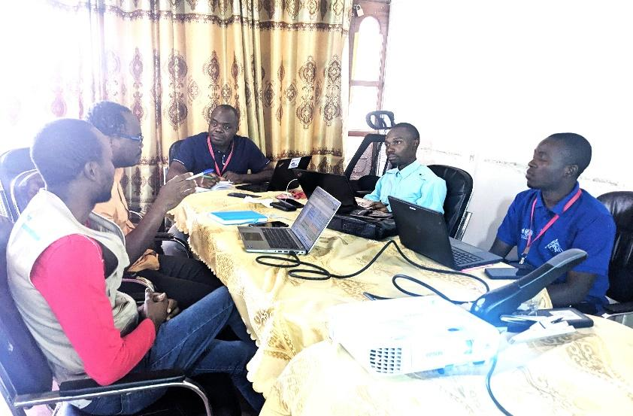
At the beginning of the process, the national coordination teams met to examine the feasibility of the action. After reviewing the obstacles and challenges to strengthening collaboration between child protection and education, the two teams explored possible solutions to achieve the objectives. These discussions revealed that the obstacles to collaboration at the operational level could be overcome by reversing the approach. Instead of a top-down approach, it would be wise to adopt a bottom-up perspective through a pilot phase in North Kivu.
Essentially, this initiative should go beyond the theoretical aspects of coordination to address this change in a concrete and realistic manner. Actors should therefore identify geographical and thematic areas of convergence based on interventions already planned by the actors to ensure that they are implemented in the same communities and for the benefit of the same targets. It was recommended that the process be documented to support scaling up and also feed into strategic documents. In addition, the roles and responsibilities of each actor in the implementation of this initiative were defined. These discussions were held within each sector with all partners, with periodic updates during monthly meetings to build support. Following these preliminary discussions, the project was implemented.

Implementation
The implementation of this project began with a series of discussions between the provincial coordinators of the Child Protection Area of Responsibility (AOR) and the Education Cluster in North Kivu, under the supervision of the national teams. These discussions identified the Rushuru territory as the entry point for this initiative, given the need to concentrate the operational capacities of both sectors there. Each sector, supported by the Child Protection and Education working group coordinators in Rushuru, was tasked with mapping the actors involved in their field. It quickly became apparent that the actors present in Rushuru did not have the resources to carry out an effective intervention due to a significant reduction in funding. Areas such as Goma, Nyiragongo and Kirotshe, which had a high concentration of interventions, were then explored. However, the rigidity of the projects and the distance between the intervention areas made efficient coordination difficult. The Kirotshe Health Zone in Masisi Territory was then identified as the entry point for this pilot project.

Choice of Area and Coordination
In Kirotshe, ACAD, BIFERD, NRC and SCI were running projects covering child protection, education, food security, water, hygiene and sanitation. To strengthen coordination, meetings were organised, bringing together national and provincial coordinators and project managers to identify possible geographical overlaps and complementary and joint activities. A matrix was posted online to collect contributions from project managers.
Given that NRC was already involved in a project with a strong focus on education in the implementation phase, the coordination of interventions was structured around its existing activities. ACAD, BIFERD and SCI, with packages mainly focused on protection, were therefore invited to align their complementary actions with the six schools and communities targeted by NRC. This approach aimed to avoid the juxtaposition of interventions in education and child protection, favouring simultaneous, coherent and integrated actions.

Thanks to the flexibility of the actors involved, a reference map was established to guide implementation and facilitate joint monitoring of activities. In addition, for joint actions, a clear division of areas of intervention was decided upon in order to reduce duplication. Partners also harmonised their action plans and shared them with the coordination teams. We will now examine the results achieved at the end of these interventions.

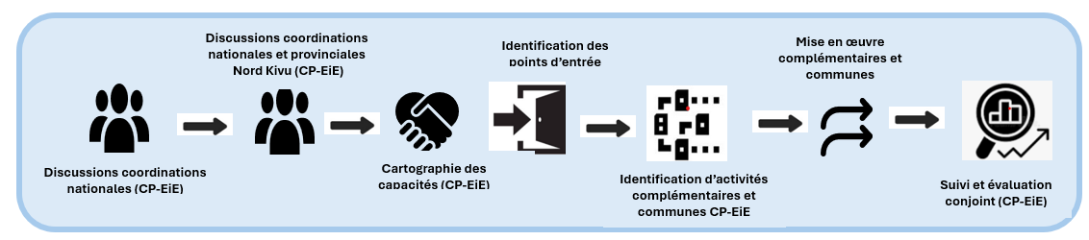

Main Results
At the end of this intervention, 6,800 children (3,871 girls and 691 disabled children) from schools in Bweremana, Shasa and Kirotshe benefited from a package of complementary activities covering education, protection, food security, water, hygiene and sanitation. The table below provides details of the activities and targets. The following table provides further details.

 | Activities | Organisations | Sector | Total | Girls | PvH
Additional activities
1 | Remedial classes | NRC | Education | 35 | 1820 | 35
2 | Teacher training on psychosocial support | NRC | Education | 6 | 31 | NA
3 | Support for the implementation of school improvement plans | NRC | Education | 6 | NA | NA
4 | Support for the implementation of the environmental protection plan | NRC | Protection | 6 | NA | NA
5 | Training of parent committees on good governance | NRC | Protection | 40 | NA | NA
6 | Support for the implementation of risk reduction plans | NRC | Protection | 6 | NA | NA
7 | Dissemination of gender awareness messages | SCI/BIFERD | Protection | 10 | 514 | 8
8 | Psychosocial support activities | ACAD | Protection | 10 | 520 | 100
9 | Rehabilitation of water points | SCI/BIFERD | WASH | 240 | 12359 | 1008
1 | Rehabilitation of impluvium | SCI/BIFERD | WASH | 1650 | 84 | 132
1 | Establishment, training and equipping of water point management committees | SCI/BIFERD | WASH | 5 | 2 | 4
12 | Development of waste disposal sites | SCI/BIFERD | WASH | 100 | 514 | 80
13 | Distribution of agro-pastoral kits | SCI/BIFERD | SECAL | 3,000 | 1542 | 240
14 | Training and support for beneficiaries on improved agriculture | SCI/BIFERD | SECAL | 3,000 | 154 | 240
1 | Cooking demonstration and awareness-raising on good eating habits | SCI/BIFERD | SECAL | 30 | 15 | 2
Joint activities
1 | Distribution of school kits | ACAD, NRC, SCI/BIFERD | Education | 1 | 65 | 75
2 | Organisation of creative/recreational activities | ACAD, NRC, SCI/BIFERD | Education | 21 | 132 | 75
3 | Activities Identification, documentation, research, verification, and reunification | ACAD, NRC, SCI/BIFERD | Protection | 100 | 50 | 10
4 | Support for the development of action plans for community protection networks | SCI/BIFERD | Protection | 8 | 35 | 2
5 | Activities Identification, documentation, research, verification, and reunification of unaccompanied children | ACAD, SCI/  BIFERD | Protection | 60 | 20 | 0
6 | Capacity building for RECOPE, APS and FAT on child protection | ACAD, NRC, SCI/BIFERD | Protection | 1 | 4 | 2
7 | Strengthening RECOPE | ACAD, NRC, SCI/BIFERD | Protection | 1,000 | 65 | 75
8 | Establishment of children's parliaments and children's committees in schools | ACAD, NRC, SCI/BIFERD | Protection | 21 | 132 | 7
9 | Construction/rehabilitation of latrines and maintenance | NRC, SCI/  BIFERD | WASH | 10 | 5 | 10

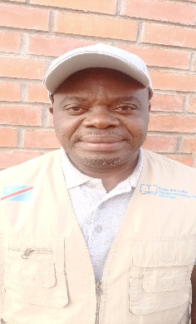
These results have been warmly welcomed by the coordination teams in the education and child protection sectors. For the provincial coordinators of these two areas in North Kivu, this is the fulfilment of a dream that initially seemed almost impossible.

This is clear from the comments of Déo Bahimba, provincial coordinator of the North Kivu education cluster: "I admit that at the beginning, I was really perplexed about the outcome of this project. Now that the results are visible on the ground, I can only rejoice at the promising prospects that lie ahead."
Déo Bahimba

Isaac Buhazi, provincial coordinator for Child Protection, shares this optimism: "These results are a real source of motivation for us. We will commit ourselves even more to this area of collaboration so that actors from both sectors can continue to implement complementary or joint activities for the benefit of children."
Isaac Buhazi

Joint Monitoring Sessions
On 20 June 2025, the national coordinator for the Education cluster, the provincial coordinators for DDR Child Protection and Education, and teams from ACAD, SCI and BIFERD carried out a monitoring mission in Kirotshe. The aim of the mission was to verify the joint implementation of education and child protection activities. After meeting with the local education authority, the teams visited schools in Bihira and Muganza. They met with school principals and the chair of the parents' committee at the school in Bihira.

Discussions with these stakeholders revealed that activities are being carried out in a coordinated manner, with a positive impact on children. The school principal said: " recreational activities promote the well-being of pupils. Some children who were previously withdrawn are becoming more open and participatory. Thanks to awareness-raising on the dangers of mines, pupils report any suspicious objects, thereby contributing to everyone's safety." " For the headteacher of the school in Bihira, "this complementarity makes the school more attractive and increases attendance, which will undoubtedly improve the quality of learning."

Lessons Learned
The implementation of this project has yielded a set of lessons that must be capitalised on and disseminated in order to improve collaboration between the Child Protection DDR unit and the education sector.

One of the main findings is that the flexibility of the projects implemented by actors in both sectors provides significant scope for identifying geographical and thematic synergies conducive to complementary interventions. However, this requires a transformation of current approaches to project financing and design. It is therefore imperative to actively advocate with donors and programme designers to ensure that projects have sufficient flexibility to adapt to opportunities for coordination on the ground.

Another key lesson concerns the need to jointly define complementary and joint activities upstream. This shared identification provides a basis for thematic alignment between the two sectors. Once this alignment has been established, coordination can focus on identifying geographical convergence, thereby making the planning and implementation process more effective.

The involvement of operational partners, but also of institutional actors, in particular the authorities responsible for the sectors concerned, at all stages of the process is also crucial. Their active participation, facilitated by regular updates, strengthens the collective understanding of the value of intersectoral collaboration and allows for better ownership of joint interventions.

This initiative is a real pillar of coordination. By bringing together actors from two complementary sectors around the same table, it promotes a coherent, multi-sectoral approach geared towards a shared objective: responding holistically and in an integrated manner to the complex needs of children. It also helps to avoid duplication, pool resources, document good practices and feed into existing technical frameworks, while remaining fully anchored in the principles of coordinated humanitarian action.

Main Challenges and Limitations
In the following paragraphs, we will discuss the challenges and limitations that have marked this journey.

Challenges
The main challenge encountered was the underfunding of the education and child protection sectors. The initial identification of Rutshuru as an entry area was hampered by a lack of operational capacity due to a lack of resources. This lack of funding limited the mobilisation of actors. Although results were achieved with a limited number of partners, broader involvement would have increased the impact and provided a more comprehensive and coordinated response.

A major challenge was linked to the nature of the projects undertaken, which were mainly focused on rapid response, with implementation times ranging from three to six months. This time constraint complicated coordination, especially as project managers and coordinators were heavily involved in their respective responsibilities. The work was carried out under pressure, limiting opportunities for consultation. It was often difficult to find slots to organise meetings, which hampered the establishment of a smooth collaborative dynamic, despite the clear commitment of the various actors involved.

Given that human endeavour is never perfect, questions may be raised about the limitations of this initiative.

Limitations
The lack of involvement of state actors was a significant limitation of this project. Although the issue was raised, it was decided to proceed without them so as not to slow down the process, with the intention of involving them at a later stage during the documentation phase. However, their participation from the outset would have strengthened their capacities, facilitated implementation and embedded good institutional practices. This shortcoming can be corrected when the project is replicated in other provinces. How can this collaboration be strengthened beyond this project, which focused on operational aspects?

Possible Areas for Collaboration
A series of actions can be suggested at the strategic, programmatic and operational levels to strengthen this collaboration.

Strategic/Programmatic
According to the Framework for Collaboration in PE-ESU Coordination, collaboration between these two sectors can be considered in three dimensions, in the following order:
- Level 1 : close/intersectoral collaboration
- Level 2: partial/coherent collaboration and:
- Level 3: basic collaboration/information sharing.
Activities can take place at all levels of the humanitarian cycle, from needs assessment to implementation, with concrete examples of integration for each phase. The table below, based on the PESU-ESU collaboration framework, illustrates the types of complementary or joint activities that are possible at different stages of the cycle (see table below).
Humanitarian programming cycle | Child protection and education activities in emergencies
 | Strategic/programmatic | Operational
Needs assessment, identification and analysis | -Joint review of secondary data  -Joint needs assessment Education  Child protection  -Harmonised sectoral assessment  Collaborative sector assessment | -Joint review of secondary data  -Joint needs assessment Education  Child protection  -Harmonised sector assessment  Collaborative sector assessment  -Joint update of PE and ESU risks  -
Strategic planning | -Development of a joint minimum package of activities (common and complementary);  -Development of joint guidance notes;  -Formulation of strategic objectives, indicators and a joint monitoring system  -Developing common indicators | -Dissemination of joint guidance notes  -Dissemination of the joint minimum package  -Development of a harmonised PE and ESU response plan
Resource mobilisation | -Develop joint advocacy messages;  -Joint development of allocation strategies for available funding (ECW, DRC Humanitarian Funds)  -Joint development of activity costs | -Organising joint PE-ESU advocacy notes to respond to children's needs.  -Conduct joint resource mobilisation campaigns.
Implementation, monitoring and evaluation | -Development of a joint monitoring grid  - Development of a framework for monitoring recommendations  - Develop shared dashboards  - Organising and facilitating collaborative training sessions  -Establishment of joint task forces (evaluation working group, school safety working group, etc.)  -Participation in meetings for each sector  -Documentation of PE-ESU best practices  - Developing integrated work tools (communication tools, etc.) | - Joint organisation of back-to-school campaigns  -Contextualisation of the joint monitoring grid  -Collecting feedback from children  Organisation of joint meetings  Collaborative organisation and facilitation of training sessions  Organisation of joint missions  Coordination of complementary or joint interventions  Support for documenting PE-ESU best practices  -Organising impact assessment sessions and capitalising on lessons learned

Key points from a discussion between education and protection actors during a child assessment as part of a multisectoral needs assessment in North Kivu in January 2025.

